LCC Pico Board Overview
Documentation, source and gerbers for boards may be found at: https://github.com/bocabob/LCC-RPi-Pico-Board

Evolution
The LCC Pico development boards evolved from LocoNet designs dating back to 2021. These early turntable boards used Arduino Nanos and depended on turnout commands for indexing to hard-coded stepper positions. Fascia panel input was desired so a keypad version was developed. This proved to be cumbersome, so a small touch screen was added with a Mega processor. The screen size needed to increase to nine inches for usability so the Raspberry Pi Pico processor was selected. For me, the Pico represents the ‘Goldilocks’ processor of very good function, technical stability, and the easy-to-use Arduino IDE. Moving to the Pico enabled LCC migration in 2024 when the Single Thread library began to support the RP2040 processor family. With the OpenLcbCLib, full protocol support was enabled.

Families
There are two basic designs, the Node and the Stepper. The Stepper provides for a stepper motor driver and dedicates supporting GP pins. The Node provides 16 GP pins through two 10P IDC connectors. While it will work with either the Pico or Pico2, the latter is recommended due to enhanced capabilities.

Common Features

Power
The boards provide dual switching power output of 3.3V and 5V with input either from the LCC CAN bus or an external power source between 8 and 15 volts. The boards may be configured to inject power to the CAN bus or to isolate power for either or both of the CAN bus jacks. Auxiliary power outputs for both 3.3V and 5V are available on the board.

CAN Bus Control
While there is an early design that uses the MCP251863 integrated CAN controller and transceiver, later designs settled on the MCP2518 and MCP2562 discrete hardware components (chips) for the LCC interface. Both work fine, it is just easier to hand solder the discrete chips.

Non-Volatile Memory (NVM)
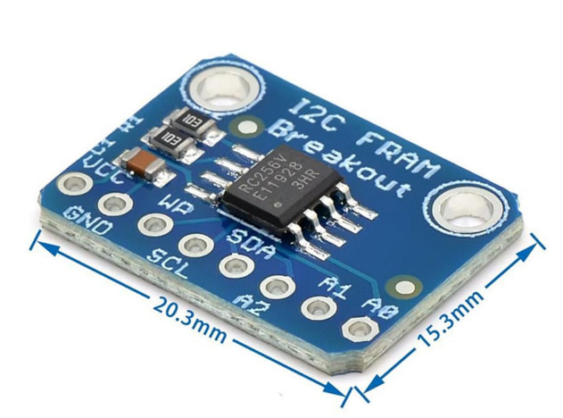
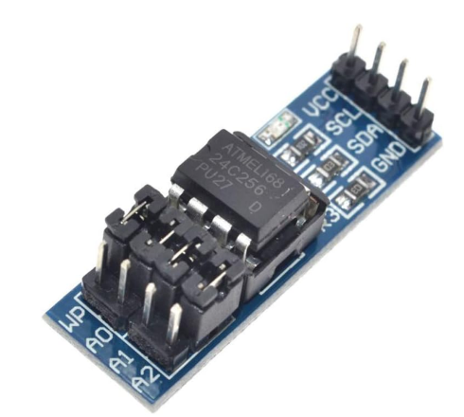
I2C nonvolatile memory should be used to reduce strain on the Pico flash. External NVM may be attached to either a I2C header, the FRAM Breakout header, or soldered down to the IC5 footprint. If either of the latter two choices are used, the I2C Address jumpers may be used to select non-default addresses or implement write protection. Otherwise, these would be functions of the module plugged into the I2C header.
A typical part would be a module utilizing an AT25C256 chip (left) or RC256V FRAM (right).
Parts compatible with the following should work for soldering to the footprint on the board.
- BR24G512F-3AGTE2 I2C BUS(2-Wre) 512K or other sizes with equivalent pinouts
- MB85RC256VPF-G-BCERE1 256kbit FRAM with I2C

I2C
I2C is used to address NVM. One or both of the available I2C channels on the Pico have headers on the board for external devices. Care should be taken should you attach peripherals to the same channel as the NVM lest there be interference. Some I2C devices will require 5 volts and so there is selection via jumper between the two available voltages.

Buttons
As there is no reset button on the Pico, one is provided on the board. There is also a header so that a button may be wired in for remote reset. There is also provision for blue and gold buttons should these be desired. Later designs have LEDs for these two buttons.

IDC Connections
GP pins and other connections are available via 10P IDC connectors. Pinouts may vary but are printed on the board and in the respective board user guide. Power is provided on pins 5 & 6 and is typically selectable except for the Turntable connector on the Stepper board.
The higher GPIO pins are used on the 2.8 Node board for the second IDC connector making the analog pins usable for node peripherals.

Node 2.8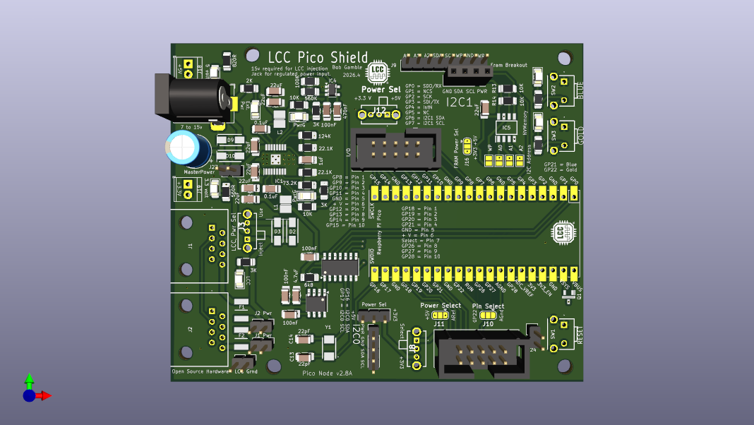
This node exposes the analog GPIO pins as an alternate implementation. Other than that, it has essentially the same functionality as Node 2.7.

Node 2.7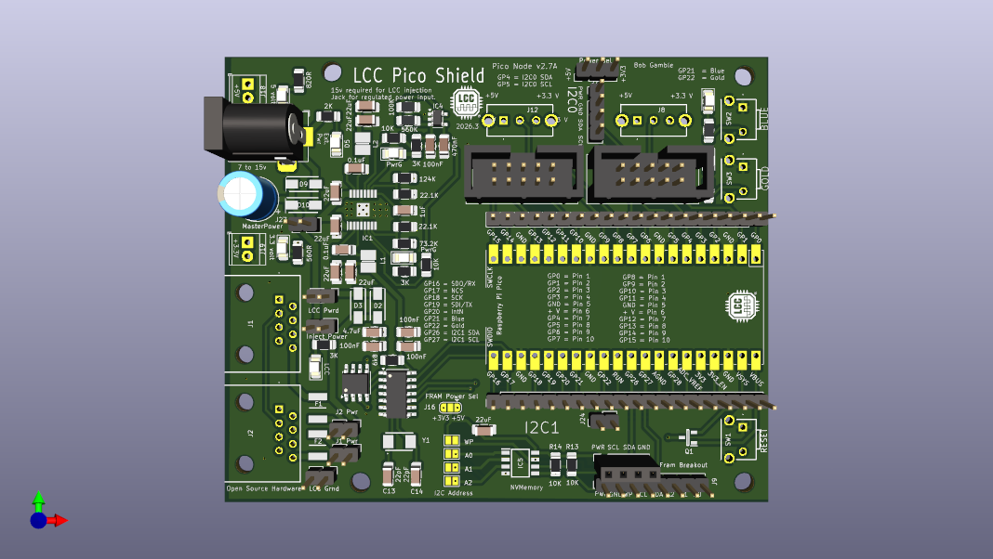
This node drives two 10P IDC connectors with a total of 16 GPIO pins. It is intended to drive servos and lights or to take inputs from detectors or buttons.

Stepper 2.7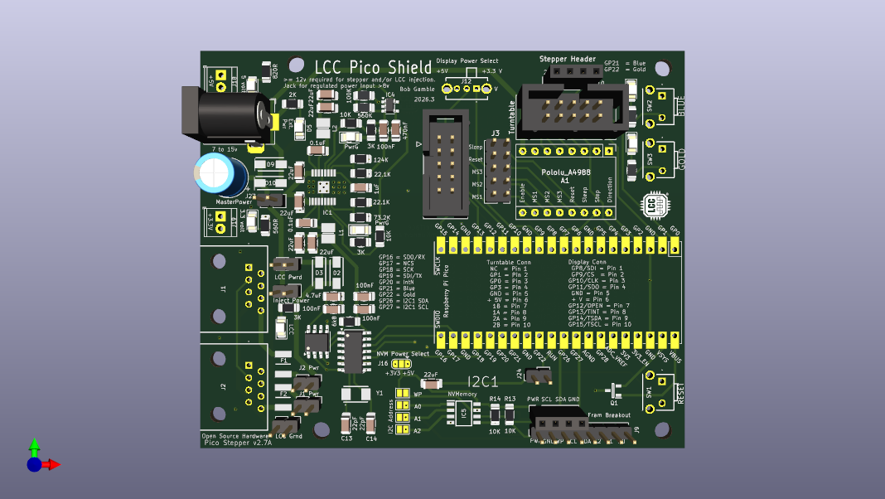
This node has provision for a stepper motor driver and is intended to control a turntable and SPI connected display.

Stepper 2.4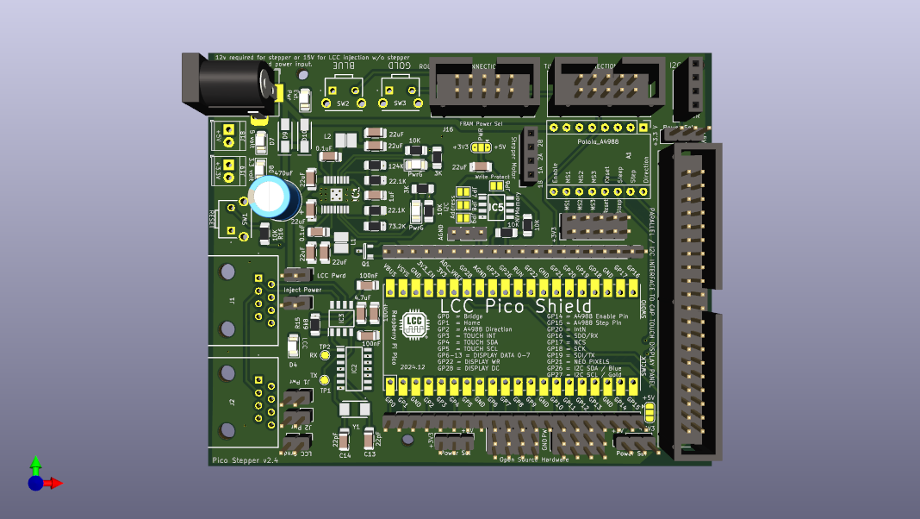
This node has provision for a stepper motor driver and is intended to control a turntable and parallel connected display.

IDC Breakout Boards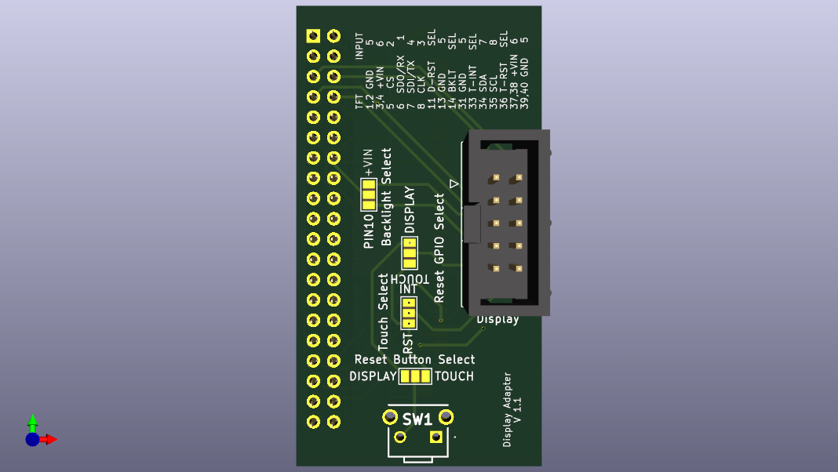
Display adapter attaches to a BuyDisplay ER-TFTM101 10.1” touchscreen for SDI display control and I2C touch. There is provision for alternate assignments of line 10 and a reset button.
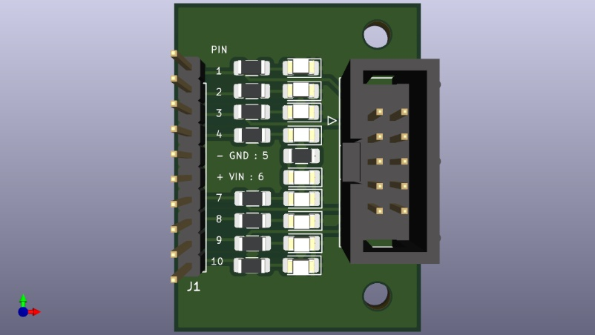
This IDC breakout has optional LEDs for testing.
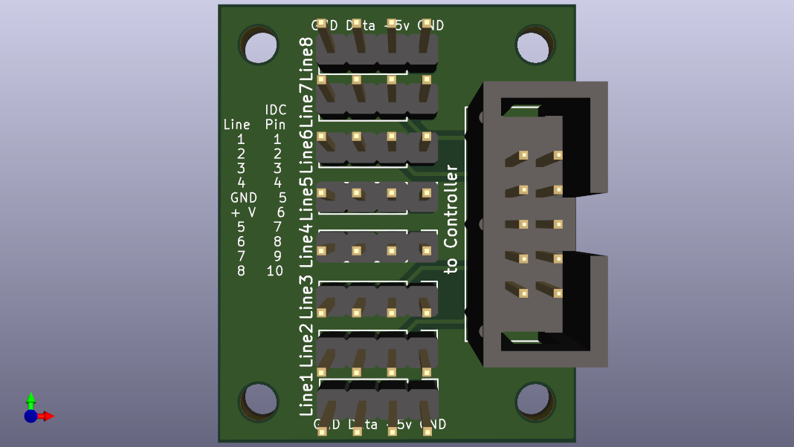
This IDC breakout has power and ground pins around the GPIO pin to facilitate connections to inputs, servos, NeoPixels, or another device.

Board Pin Assignments
 |  |  |  |  | 2.5 Node board | 2.6 Node board | 2.7 Node board | 2.8 Node board | 2.4 Stepper board | 2.7 Stepper board
1 | gp0 | SPI0 RX | I2C0 SDA |  | header pin | header pin | I/0-1:Pin1 | ACAN_RX_PIN | Bridge sensor | TT-Pin3 - Bridge sensor
2 | gp1 | SPI0 CSN | I2C0 SCL |  | header pin | header pin | I/0-1:Pin2 | ACAN_CS_PIN | Home sensor | TT-Pin2 - Home sensor
3 | GND
4 | gp2 | SPI0 SCK | I2C1 SDA |  | Npixel 1 | Npixel 1 | I/0-1:Pin3 | ACAN_CSK_PIN | Stepper Direction | Stepper Direction
5 | gp3 | SPI0 TX | I2C1 SCL |  | Npixel 2 | Npixel 2 | I/0-1:Pin4 | ACAN_TX_PIN | Touch Interrupt | TT-Pin4 - NeoPixel data line
6 | gp4 | SPI0 RX | I2C0 SDA |  | I2C0 SDA | I2C0 SDA | I/0-1:Pin7 / I2C0 SDA | ACAN_INT_PIN | Touch SDA | header pin
7 | gp5 | SPI0 CSn | I2C0 SCL |  | I2C0 SCL | I2C0 SCL | I/0-1:Pin8 / I2C0 SCL | header pin | Touch SCL | header pin
8 | GND
9 | gp6 | SPI0 SCK | I2C1 SDA |  | Npixel 3 | Npixel 3 | I/0-1:Pin9 | I2C1 SDA | Display Data 0 | Stepper Enable
10 | gp7 | SPI0 TX | I2C1 SCL |  | Npixel 4 | Npixel 4 | I/0-1:Pin10 | I2C1 SCL | Display Data 1 | Stepper Step
11 | gp8 | SPI1 RX | I2C0 SDA |  | I/0-1:Pin10 | I/O - Pin10 | I/0-2:Pin1 | I/0-1:Pin1 | Display Data 2 | I/0-2:Pin1 : SPI1 SDI
12 | gp9 | SPI1 CSn | I2C0 SCL |  | I/0-1:Pin9 | I/O - Pin9 | I/0-2:Pin2 | I/0-1:Pin2 | Display Data 3 | I/0-2:Pin2 : SPI1 CS
13 | GND
14 | gp10 | SPI1 SCK | I2C1 SDA |  | I/0-1:Pin8 | I/O - Pin8 | I/0-2:Pin3 | I/0-1:Pin3 | Display Data 4 | I/0-2:Pin3 : SPI1 CLK
15 | gp11 | SPI1 TX | I2C1 SCL |  | I/0-1:Pin7 | I/O - Pin7 | I/0-2:Pin4 | I/0-1:Pin4 | Display Data 5 | I/0-2:Pin4 : SPI1 SDO
16 | gp12 | SPI1 RX | I2C0 SDA |  | I/0-1:Pin4 | I/O - Pin4 | I/0-2:Pin7 | I/0-1:Pin7 | Display Data 6 | I/0-2:Pin7 : Touch I2C0 SDA
17 | gp13 | SPI1 CSn | I2C0 SCL |  | I/0-1:Pin3 | I/O - Pin3 | I/0-2:Pin8 | I/0-1:Pin8 | Display Data 7 | I/0-2:Pin8 : Touch I2C0 SCL
18 | GND
19 | gp14 | SPI1 SCK | I2C1 SDA |  | I/0-1:Pin2 | I/O - Pin2 | I/0-2:Pin9 | I/0-1:Pin9 | Stepper Enable | I/0-2:Pin9 : Touch INT
20 | gp15 | SPI1 TX | I2C1 SCL |  | I/0-1:Pin1 | I/O - Pin1 | I/0-2:Pin10 | I/0-1:Pin10 | Stepper Step | I/0-2:Pin10 : open
21 | gp16 | SPI0 RX | I2C0 SDA |  | ACAN_RX_PIN | ACAN_RX_PIN | ACAN_RX_PIN | I2C0 SDA | ACAN_RX_PIN | ACAN_RX_PIN
22 | gp17 | SPI0 CSn | I2C0 SCL |  | ACAN_CS_PIN | ACAN_CS_PIN | ACAN_CS_PIN | I2C0 SCL | ACAN_CS_PIN | ACAN_CS_PIN
23 | GND
24 | gp18 | SPI0 SCK | I2C1 SDA |  | ACAN_CSK_PIN | ACAN_CSK_PIN | ACAN_CSK_PIN | I/0-2:Pin1 | ACAN_CSK_PIN | ACAN_CSK_PIN
25 | gp19 | SPI0 TX | I2C1 SCL |  | ACAN_TX_PIN | ACAN_TX_PIN | ACAN_TX_PIN | I/0-2:Pin2 | ACAN_TX_PIN | ACAN_TX_PIN
26 | gp20 |  | I2C0 SDA |  | ACAN_INT_PIN | ACAN_INT_PIN | ACAN_INT_PIN | I/0-2:Pin3 | ACAN_INT_PIN | ACAN_INT_PIN
27 | gp21 |  | I2C0 SCL |  | Blue Button | Blue Button | Blue Button | I/0-2:Pin4 & Blue Button | NeoPixel data line | Blue Button
28 | GND
29 | gp22 |  |  |  | Gold Button | Gold Button | Gold Button | I/0-2:Pin7 & Gold Button | Display WR | Gold Button
30 | RUN |  |  |  | Reset Button / header | Reset Button / header | Reset Button / header | Reset Button / header | Reset Button | Reset Button / header
31 | gp26 | ADC0 | I2C1 SDA |  | I2C1 SDA | I2C1 SDA | I2C1 SDA | I/0-2:Pin8 | I2C SDA / Blue Button | I2C1 SDA
32 | gp27 | ADC1 | I2C1 SCL |  | I2C1 SCL | I2C1 SCL | I2C1 SCL | I/0-2:Pin9 | I2C SCL / Gold Button | I2C1 SCL
33 | GND | A GND |  |  | header pin | header pin | header pin | I/0-2:Pin7 alternative |  | header pin
34 | gp28 | ADC2 |  |  | header pin | header pin | header pin | I/0-2:Pin10 | Display D/C | header pin
35 |  | ADC_VREF |  |  | header pin | header pin | header pin | I/0-2:Pin6 alternative |  | header pin
36 | 3v3_OUT
37 | 3V3_EN
38 | GND
39 | VSYS
40 | VBUS
 |  |  |  |  |  |  |  |  |  | TT-Pin1 - open
 | GND |  |  |  | I/0-1:Pin5 | I/0-1:Pin5 | I/0-1:Pin5 | I/0-1:Pin5 |  | I/0-1:Pin5
 | Vselect1 |  |  |  | I/0-1:Pin6 | I/0-1:Pin6 | I/0-1:Pin6 | I/0-1:Pin6 |  | I/0-1:Pin6
 | GND |  |  |  |  |  | I/0-2:Pin5 |  |  | I/0-2:Pin5
 | Vselect2 |  |  |  |  |  | I/0-2:Pin6 |  |  | I/0-2:Pin6

Software
Example node applications may be found in:
https://github.com/bocabob/LCC_RPiPico_Turntable
https://github.com/bocabob/LCC_RPiPico_Roundhouse
https://github.com/bocabob/LCC_RPiPico_PixelLights

Board:
Must use the RP2040 board library by Earle Philhower: https://arduino-pico.readthedocs.io/en/latest/install.html

LCC support:
https://github.com/openlcb/OpenLCB_Single_Thread
https://github.com/JimKueneman/OpenLcbCLib

CAN Hardware:
ACAN2517 Arduino library.

External Storage:
I2C_EEPROM Arduino library by Rob Tillaart
FRAM_I2C Arduino library by Rob Tillaart

NeoPixel:
NeoPixelBus by Makuna Arduino library (preferred)
NeoPixelConnect Arduino library by Alan Yorinks.

Other preferred libraries for the RPi Pico:

Display
#include <TFT_eSPI_RA8876.h> // display library [modified] https://github.com/bocabob/TFT_eSPI_RA8876
#include <RA8876_RP2040.h> // display library [modified] https://github.com/bocabob/RA8876_RP2040
#include "my_bb_captouch.h" //capacitive touch driver [modified] https://github.com/bocabob/my_bb_captouch

Servos
#include <ServoEasing.hpp> // great library for getting slow servo action, including bounces
#include <PCA9685_servo_driver.h>
#include <PCA9685_servo.h>

Stepper Motor
#include "AccelStepper.h" // by Mike McCauley [modified]

